16th Annual
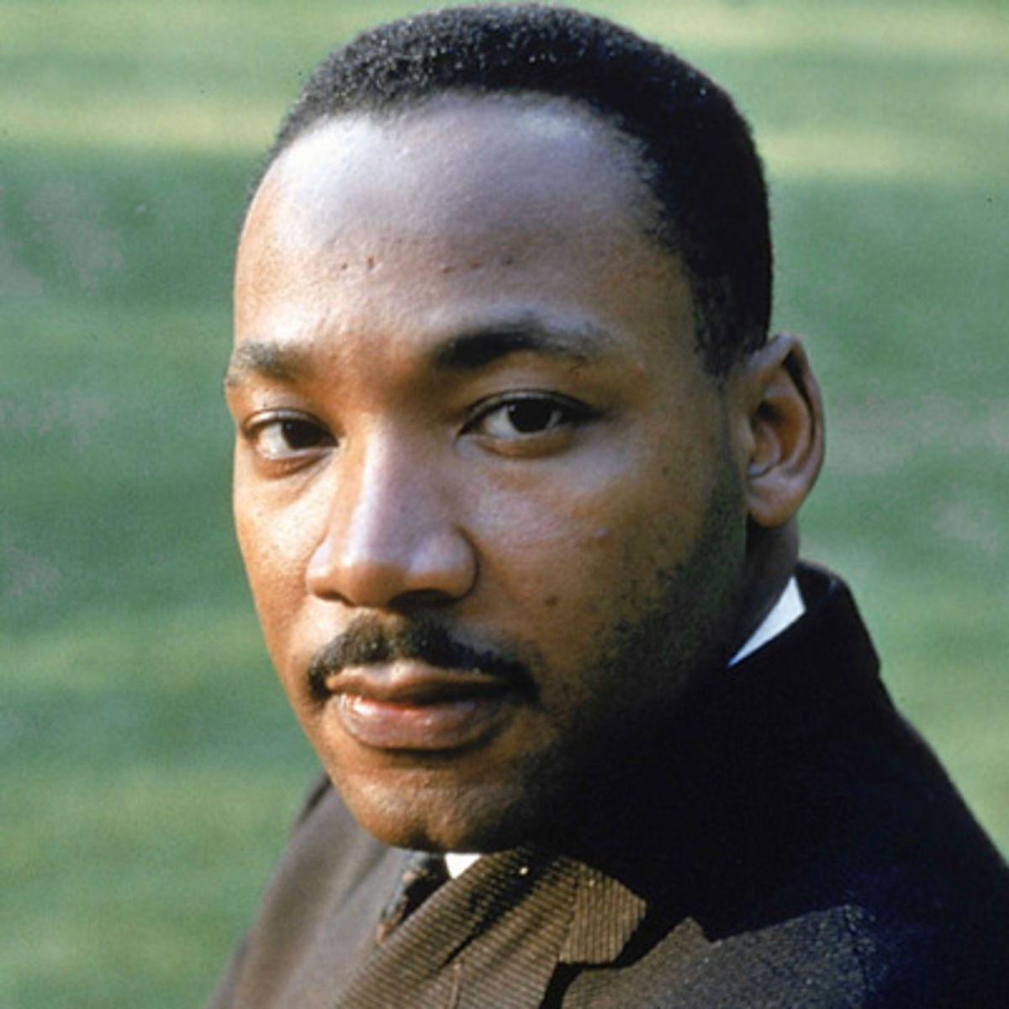
Liberty County Dr. M. L. King, Jr.
Observance Association
P. O. Box 1626
Hinesville, Georgia 31310
Email: rev_a_jackson@hotmail.com

SPONSORSHIP
Gold Corporate- $1,500.00
Corporate- $500.00
Team-$240.00
Hole- $100.00

PLAYERS- $60 per player includes two Milligans

Make contributions and fees payable to: “MLKOA”

POC:
Dr. Alvin L. Jackson
912-977-5106

Joe Ford
912-977-1077

Dr. M. L. King, Jr. Scholarship Fundraiser

Golf Tournament
April 10, 2021

Cherokee Rose Golf Course-Hinesville, GA
Check in 12:00pm Shotgun Start at 1:00pm

Door prizes, awards-longest drive, hole-in-one, closest to the hole---and lunch

REGISTER BY April 2, 2021

All proceeds benefit academic scholarships.

GOLF TOURNAMENT REGISTRATION FORM

Return completed registration form to MLKOA—Golf Tournament, P.O. Box 1626, Hinesville, GA 31310

Name: _________________________________________ Company/Organization ______________________________________

Address: ______________________________________ City/State _______________________ Phone: _____________________

Team Names: #1 _____________________________ #2 ________________________________

#3 _____________________________ #4 ________________________________

